Instructor: sir Junaid

Batch 12 and 13

Program: B.E Electrical and BS Electrical

Subject: engineering management Semester: 4th and 6th

Student Name & roll no: ______________________________________________.

Assignment 02

Total marks 10

Chapter no.2: Project Management Growth: Concepts and Definitions.

Question no.1:

How to check growth of project management? **(CLO-1) Mark: 2**

Answer: The growth of project management can be traced through topics such as roles and responsibilities, organizational structures, delegation of authority and decision-making, and especially corporate profitability.

Question no.2:

What is General Systems Management? **(CLO-2) Mark: 2**

Answer: General systems theory can be classified as a management approach that attempts to integrate and unify scientific information across many fields of knowledge. Systems theory attempts to solve problems by looking at the total picture, rather than through an analysis of the individual components.

Question no.3:

Define GSM? **(CLO-1) Mark: 2**

Answer: General system theory implies the creation of a management technique that is able to cut across many organizational disciplines – finance, manufacturing, and engineering, marketing, and so on – while still carrying out the functions of management. This technique has come to be called systems management, project management, or matrix management (the terms are used interchangeably).

Question no.04:

What is Matrix implementation scheme? **(CLO-2) Mark: 2**

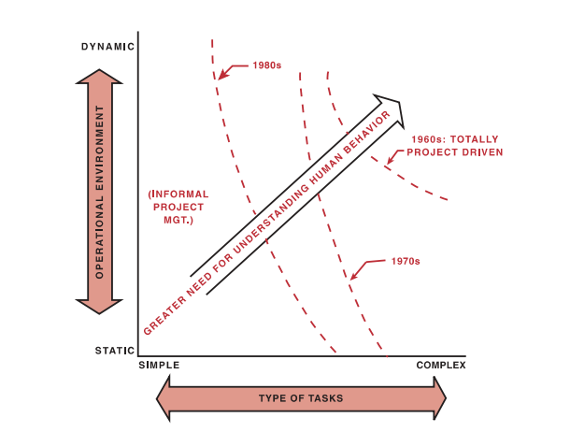

Question no.5:

Write down six imperatives of technology given by John Kenneth Galbraith?

**(CLO-1) Mark: 2**

Answer:

1. The time span between project initiation and completion appears to be increasing.
2. The capital committed to the project prior to the use of the end item appears to be increasing.
3. As technology increases, the commitment of time and money appears to become inflexible.
4. Technology requires more and more specialized manpower.
5. The inevitable counterpart of specialization is organization.
6. The above five imperatives” identify the necessity for more effective planning, scheduling, and control.

~~Question no.6:~~

~~Write down effect, if obstacles are not removed in a project?~~ **~~(CLO-4)~~**

~~Answer:~~

1. ~~Decreased profits.~~
2. ~~Increased manpower needs.~~
3. ~~Cost overruns, schedule delays, and penalty payments occurring earlier and earlier.~~
4. ~~An inability to cope with new technology.~~
5. ~~R&D results too late to benefit existing product lines.~~
6. ~~New products introduced into the marketplace too late.~~
7. ~~Temptation to make hasty decisions that prove to be costly.~~
8. ~~Management insisting on earlier and greater return on investment.~~
9. ~~Greater difficulty in establishing on – target objectives in real time.~~
10. ~~Problems in relating cost to technical performance and scheduling during the execution of the project.~~

~~Question no.7:~~

~~Write down Project management Methodologies and define?~~ **~~(CLO-6)~~**

~~Answer:~~

1. ~~Project management: The basic principles of planning, scheduling, and controlling work.~~
2. ~~Total Quality Management: The process of ensuring that the end result will meet the quality expectations of the customer.~~
3. ~~Concurrent Engineering: The process of performing work in parallel rather than series in order to compress the schedule without incurring serious risks.~~
4. ~~Scope change control: The process of controlling the configuration of the end result such that value added is provided to the customer.~~
5. ~~Risk Management: The process of identifying, quantifying, and responding to the risks of the project without any material impact on the project’s objectives.~~

~~Question no.8:~~

~~Draw integrated processes for the twenty-first century project management?~~

**~~(CLO-1)~~**

~~Answer:~~

~~

